

DEPARTMENT OF COMPUTER SCIENCE AND ENGINEERING
CS23432 – Software Construction

(REGULATION 2023)

RAJALAKSHMI ENGINEERING COLLEGE
Thandalam, Chennai-602015

Name : Steve Anderson S
Register No : 240701537
Year / Branch / Section : 2ND-YEAR / CSE
Semester | : 4TH SEMESTER
Academic Year | : 2024-2028

INDEX

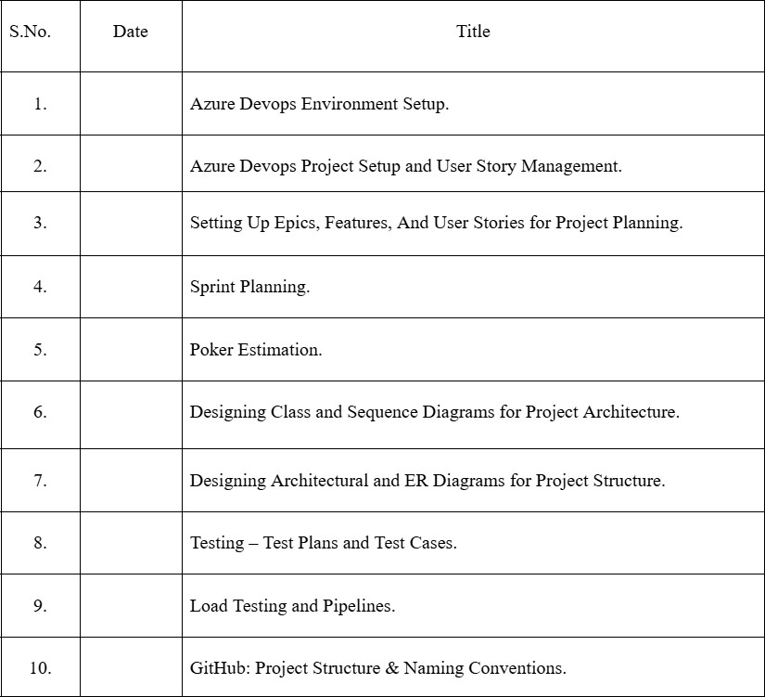

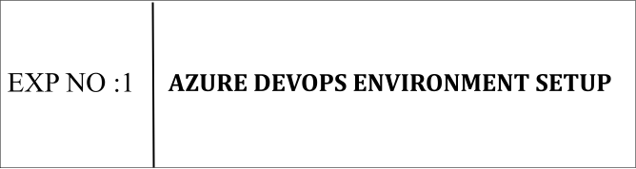

Aim:
To set up and access the Azure DevOps environment by creating an organization through the Azure portal.

INSTALLATION
- Open your web browser and go to the Azure website: https://azure.microsoft.com/en-us/get-started/azure-portal . Sign in using your Microsoft account credentials. If you don't have a Microsoft account, you can create one here: https://signup.live.com/?lic=1

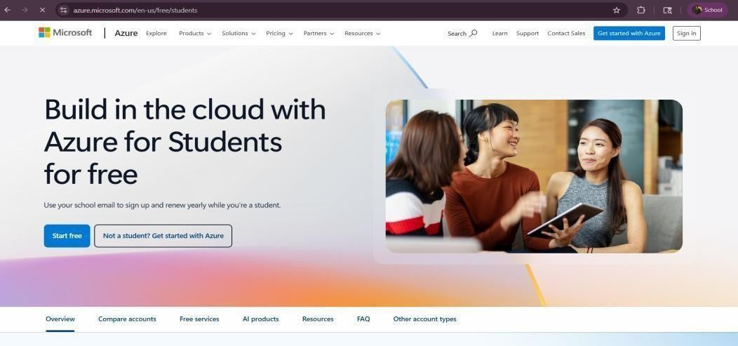

- Azure home page

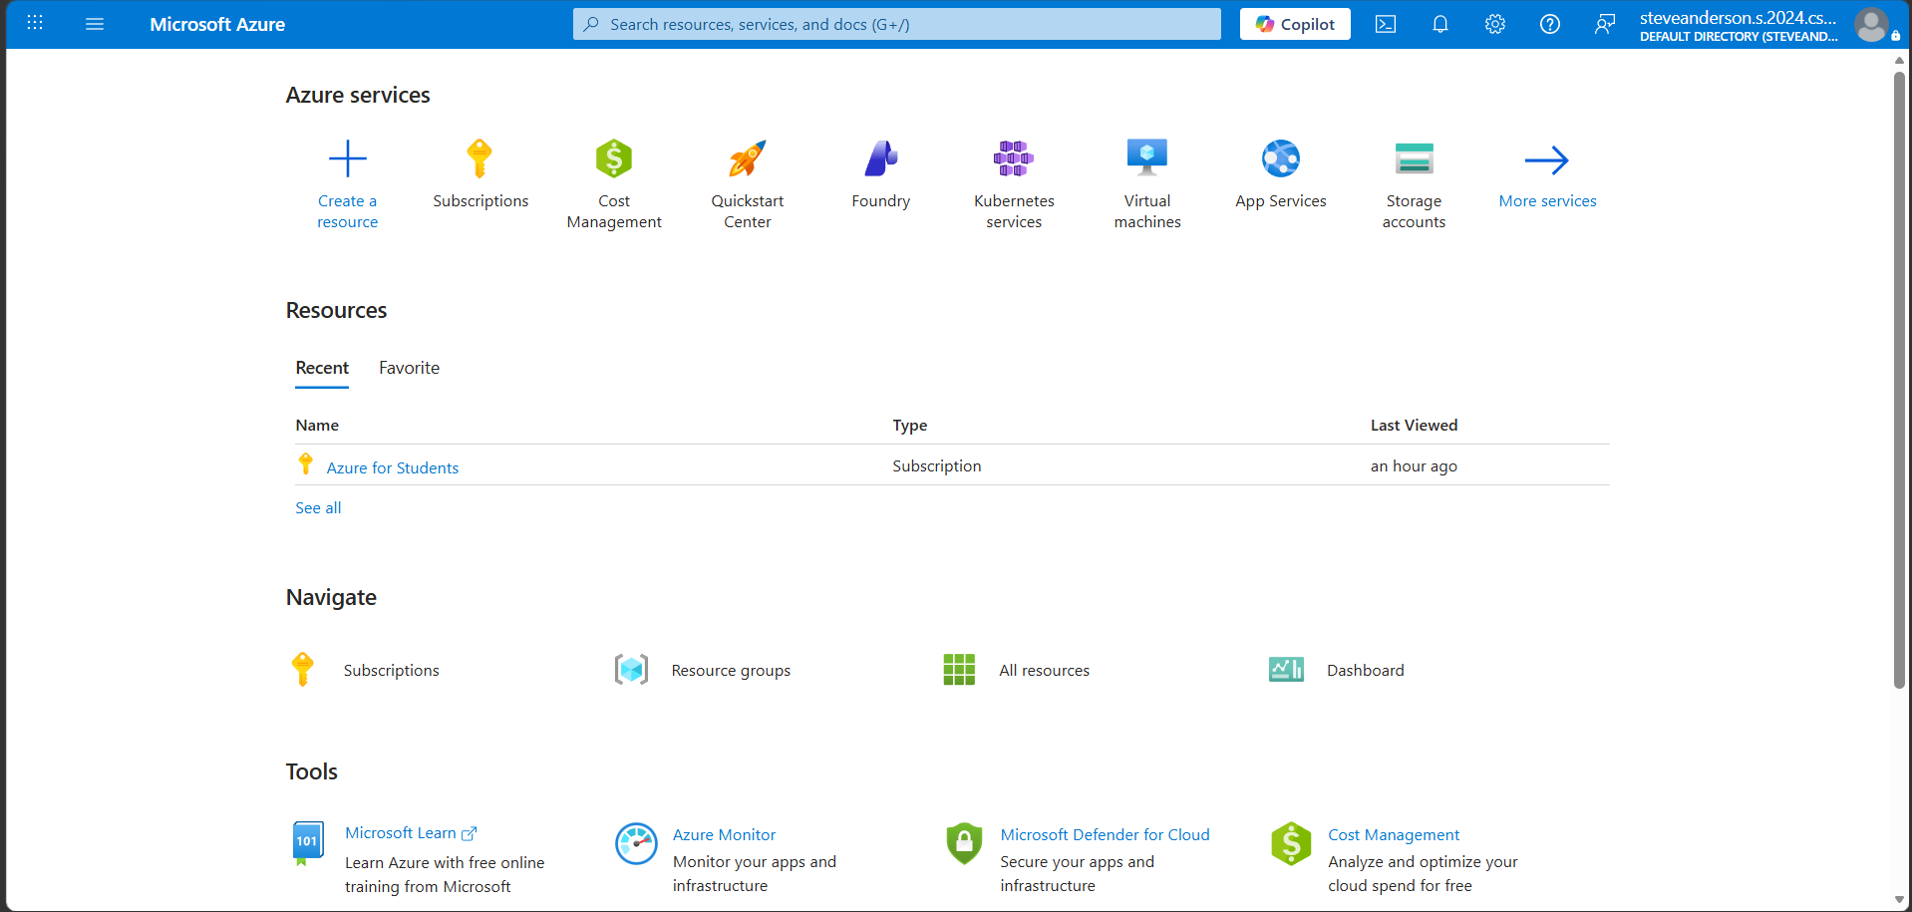

- Open DevOps environment in the Azure platform by typing Azure DevOps Organizations in the search bar.

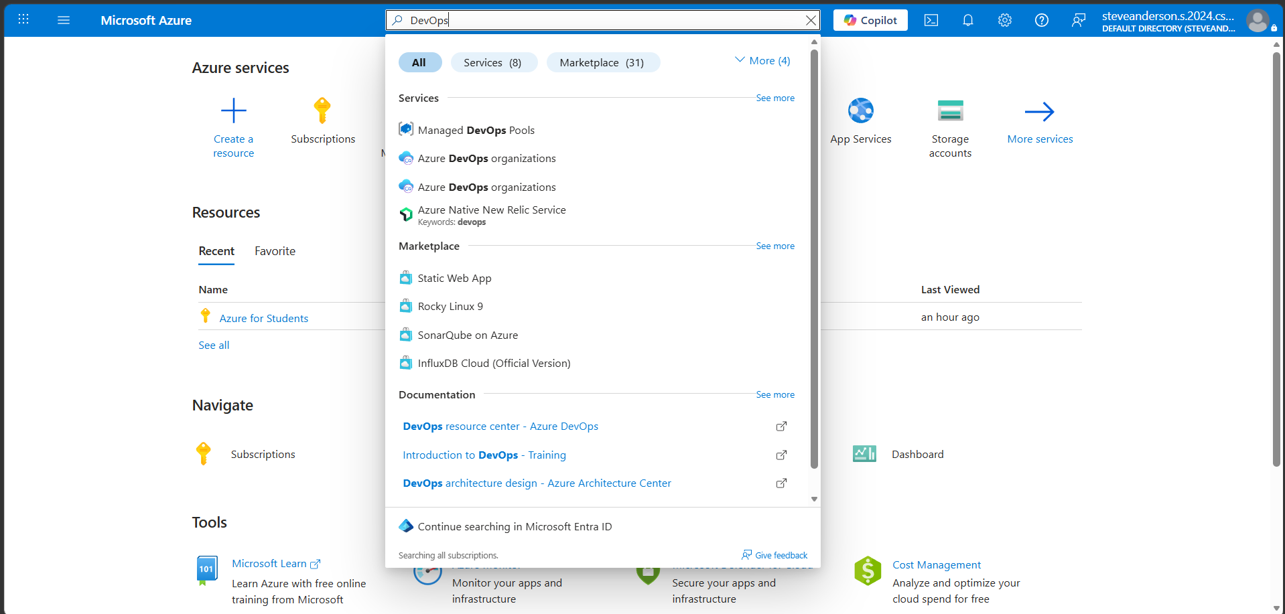

- Click on the My Azure DevOps Organization link and create an organization and you should be taken to the Azure DevOps Organization Home page.
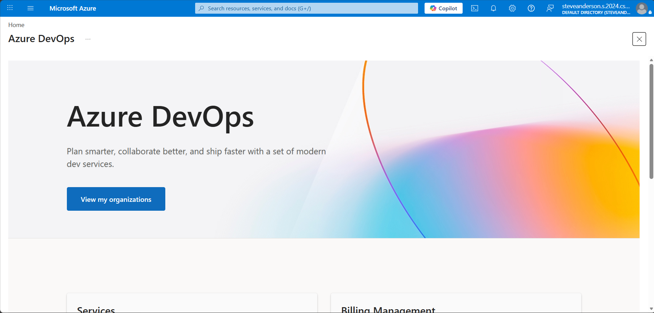

Result:
Successfully accessed the Azure DevOps environment and created a new organization through the Azure portal.

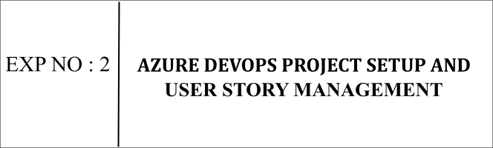

Aim:
To set up an Azure DevOps project for efficient collaboration and agile work management.
- Create An Azure Account
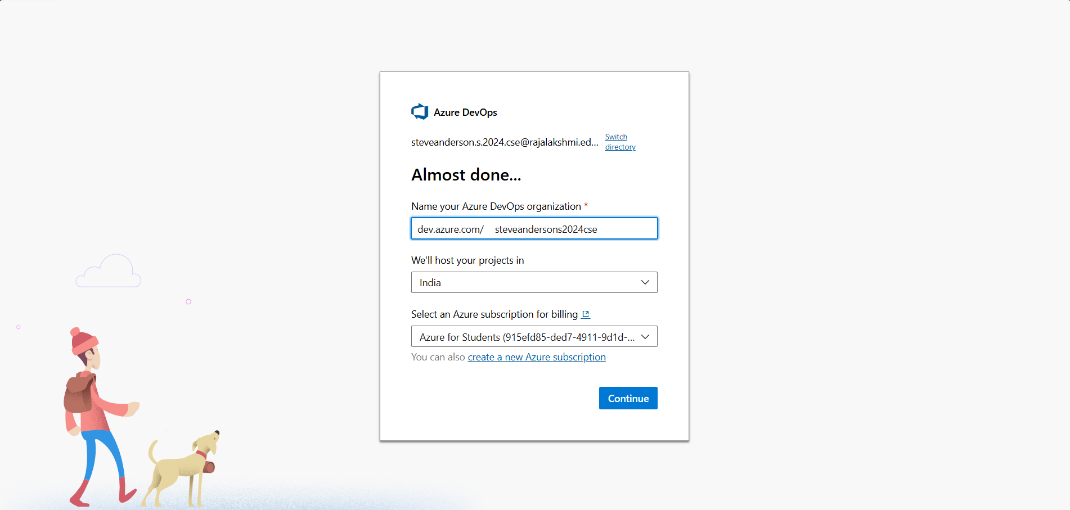
- Create the First Project in Your Organization
- After the organization is set up, you’ll need to create your first project. This is where you'll begin to manage code, pipelines, work items, and more.
- On the organization’s Home page, click on the New Project button.
- Enter the project name, description, and visibility options:
Name: Choose a name for the project (e.g., City Pulse).
Description: Optionally, add a description to provide more context about the project.
Visibility: Choose whether you want the project to be Private (accessible only to those invited) or Public (accessible to anyone).
- Once you’ve filled out the details, click Create to set up your first project.
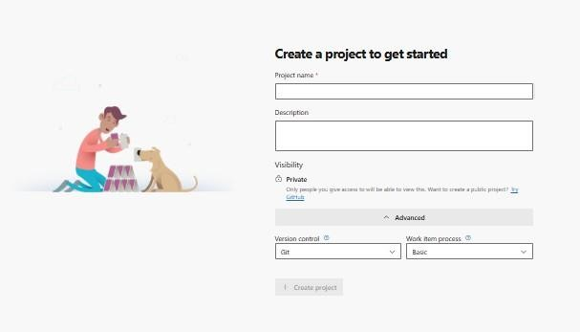
- Once logged in, ensure you are in the correct organization. If you're part of multiple organizations, you can switch between them from the top left corner (next to your user profile). Click on the Organization name, and you should be taken to the Azure DevOps Organization Home page.

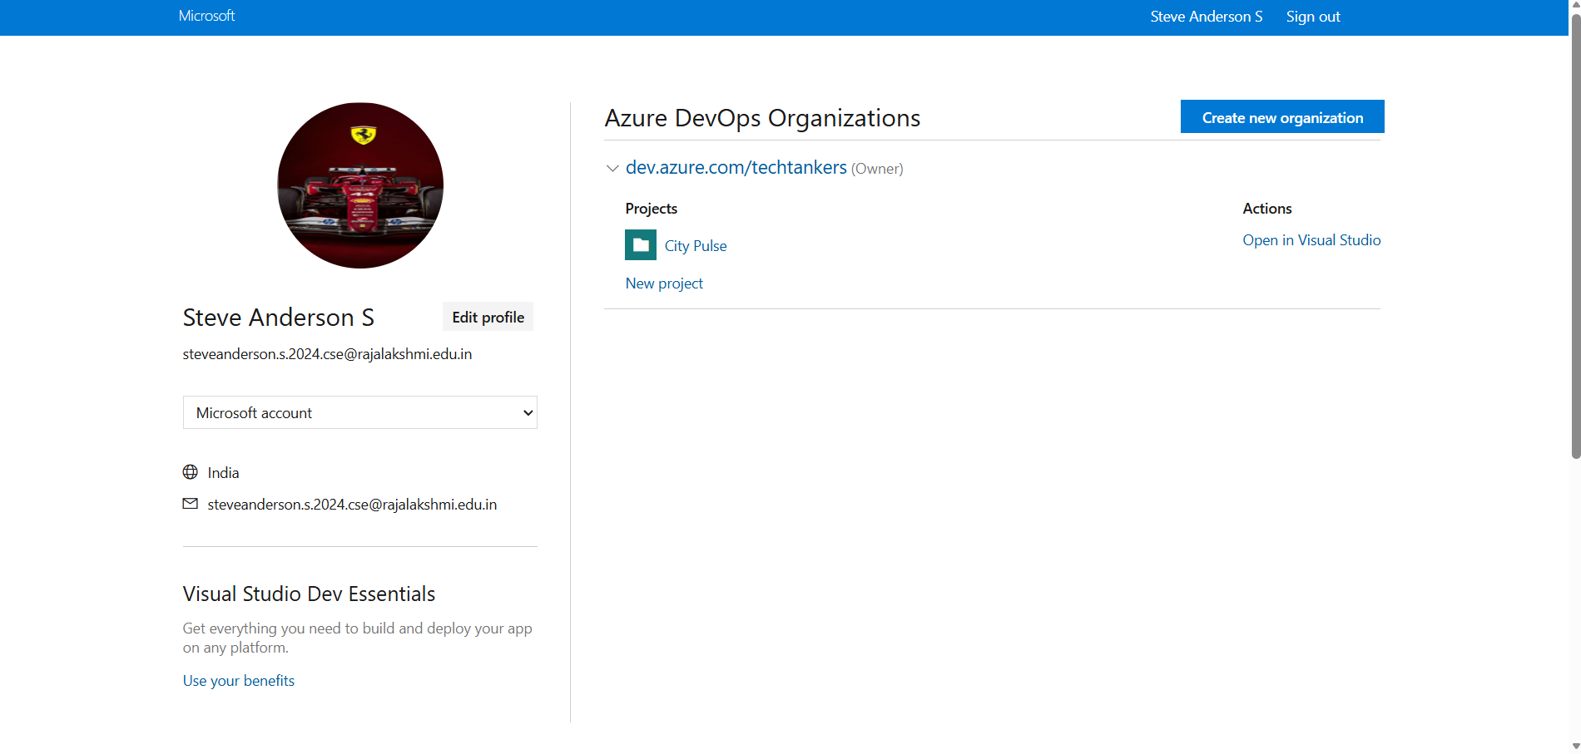

- Project dashboard

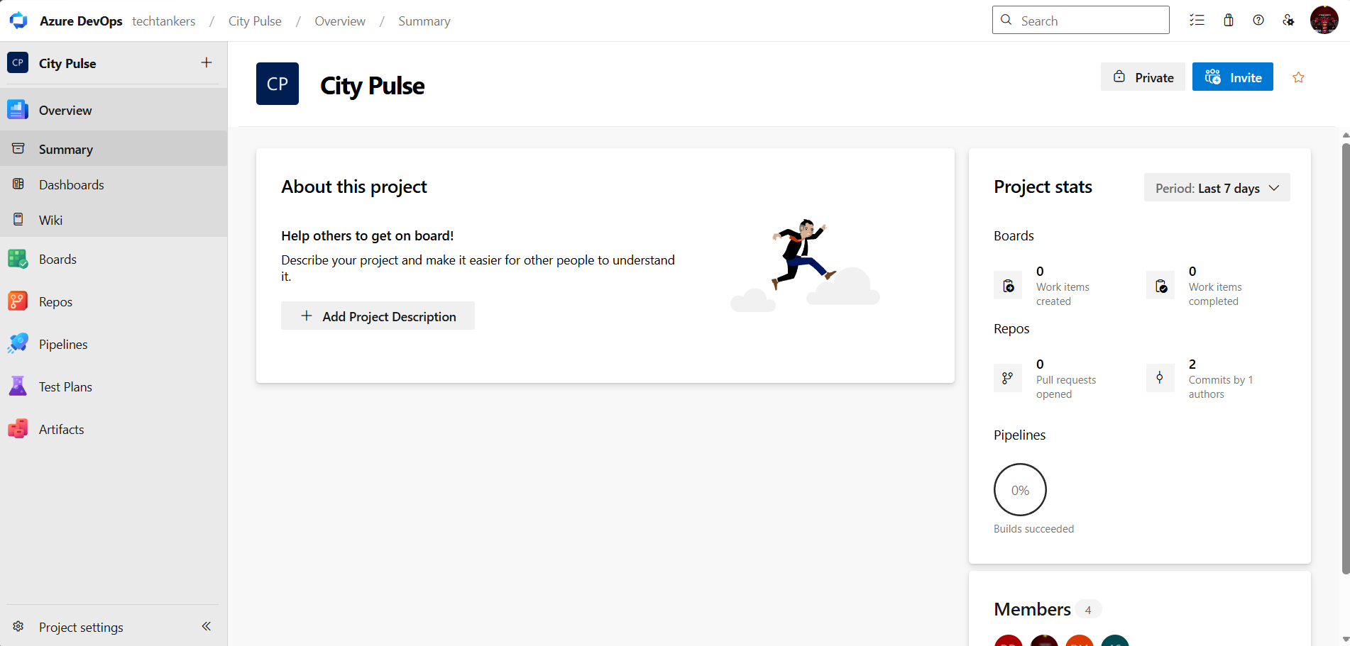

- To manage user stories:

  - From the left-hand navigation menu, click on Boards. This will take you to the main Boards page, where you can manage work items, backlogs, and sprints.
  - On the work items page, you'll see the option to Add a work item at the top. Alternatively, you can find a + button or
Add
New Work Item depending on the view you're in. From the Add a work item dropdown, select User Story. This will open a form to enter details for the new User Story.

Result:

Successfully created an Azure DevOps
project with user story management and agile workflow setup.

EXPNO : 3 | SETTING UP EPICS , FEATURES AND USER STORIES FOR PROJECT PLANNING

Aim:
To learn about how to create epics, user story, features, backlogs for your assigned project.

Create
- Epic
- Features
- User Stories
- Task
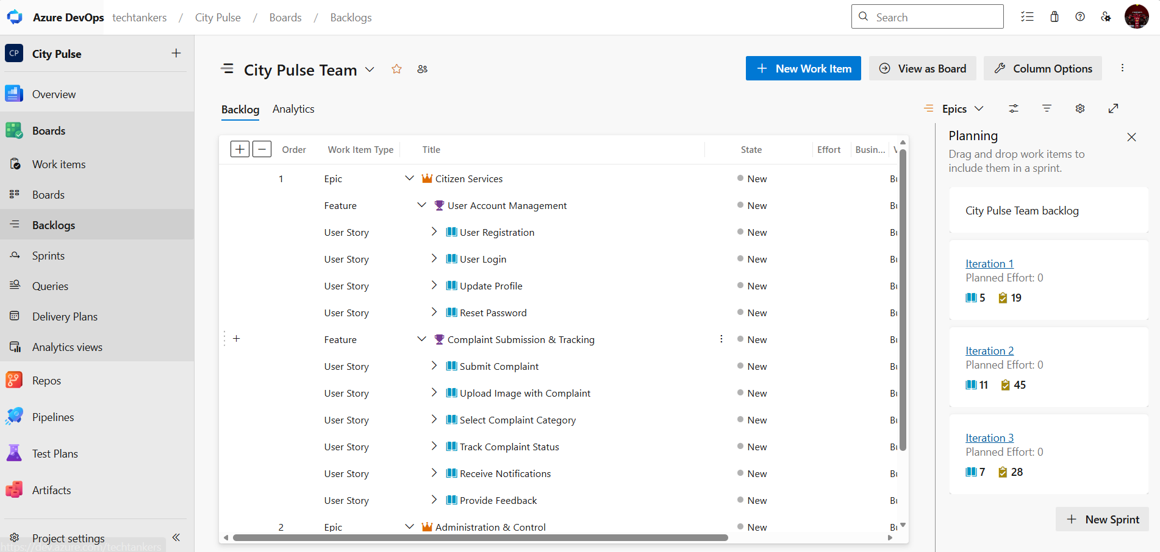
- Fill in Epics
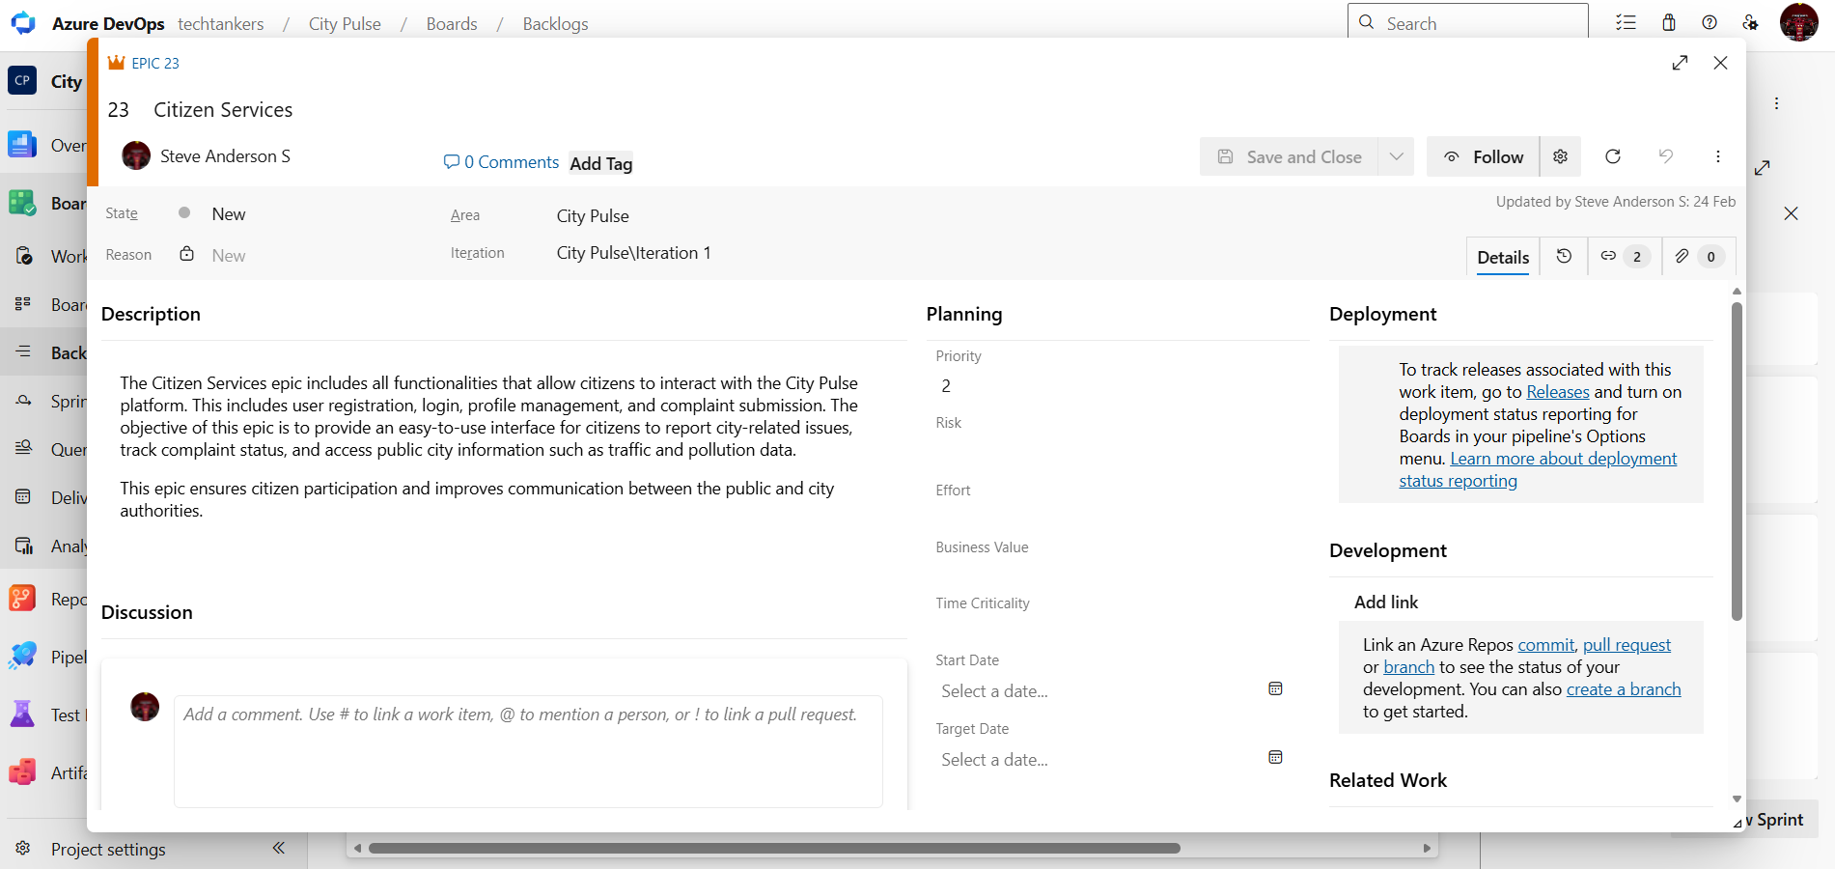

- Fill in Features
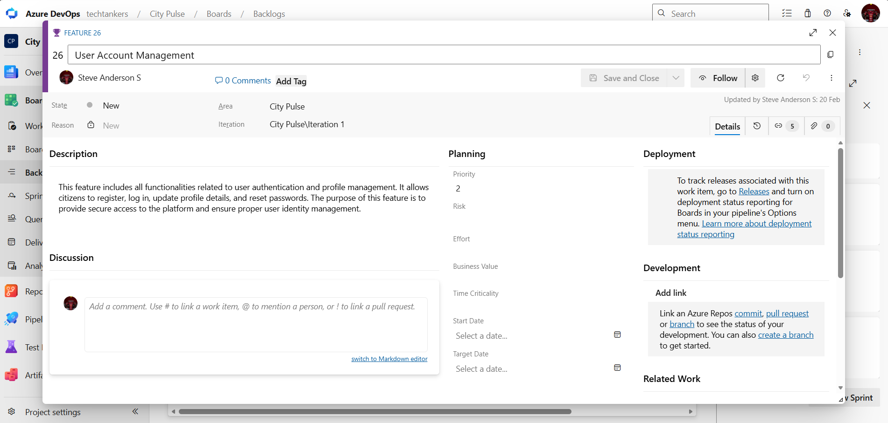
- Fill in User Story Details

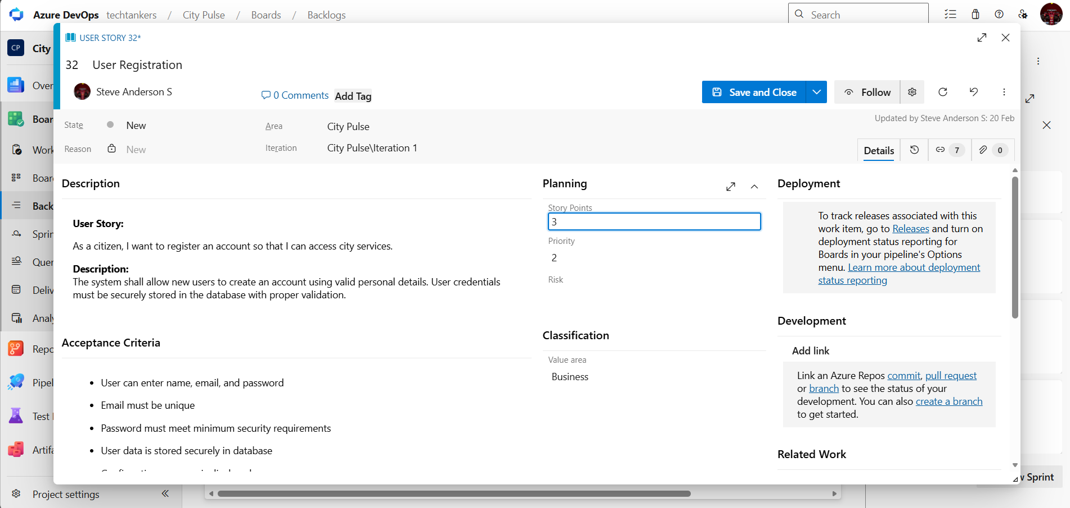
Result:
Thus, the creation of epics, features, user story and task has been created successfully for City Pulse – Smart City Management and Analytics Platform.

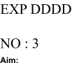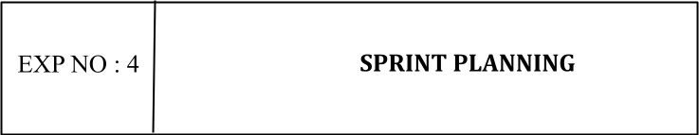

Aim:
To assign user story to specific sprint for the City Pulse – Smart City Management and Analytics Platform
Project.

Sprint Planning Sprint 1
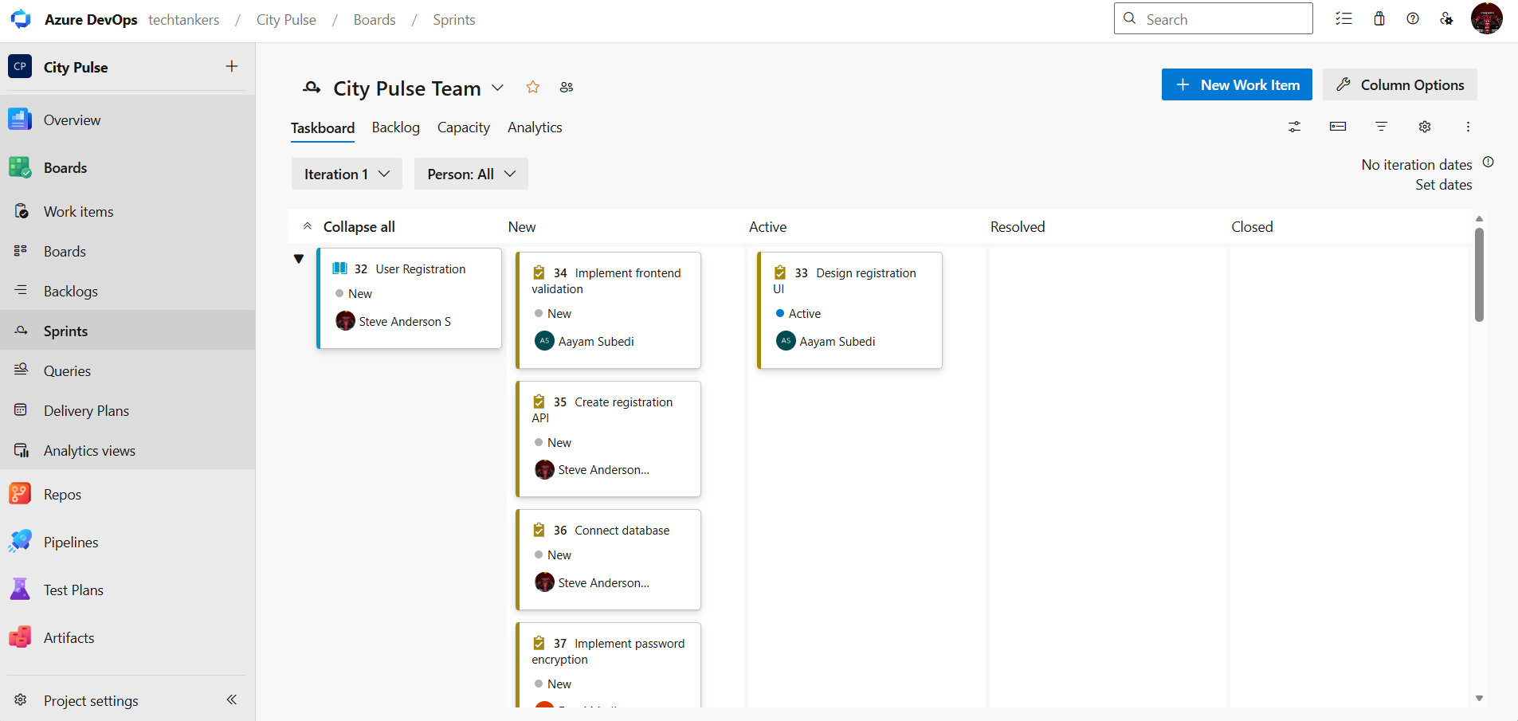

Sprint 2
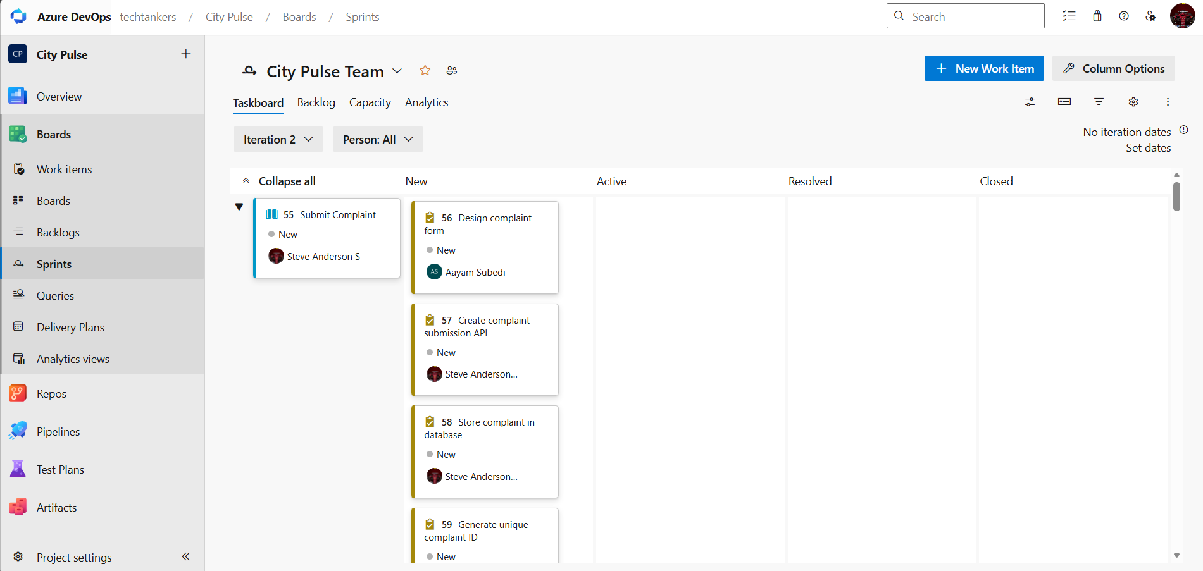

Sprint 3

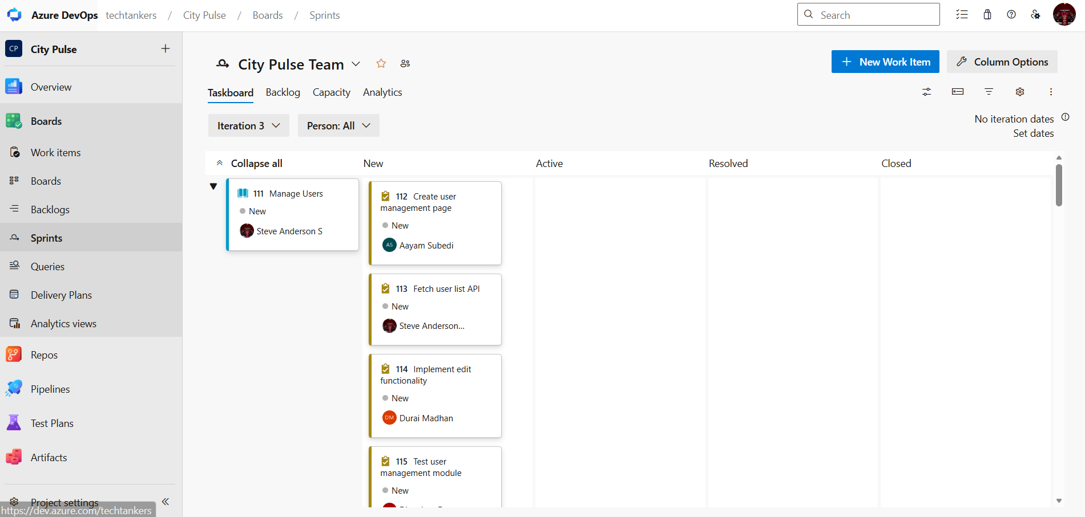

Result:
The Sprints are created for the City Pulse – Smart City Management and Analytics Platform

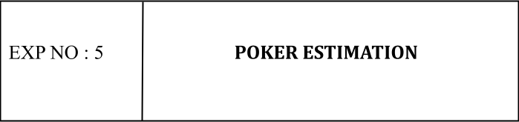

Aim:
Create Poker Estimation for the user stories - City Pulse – Smart City Management and Analytics Platform Project.

Poker Estimation

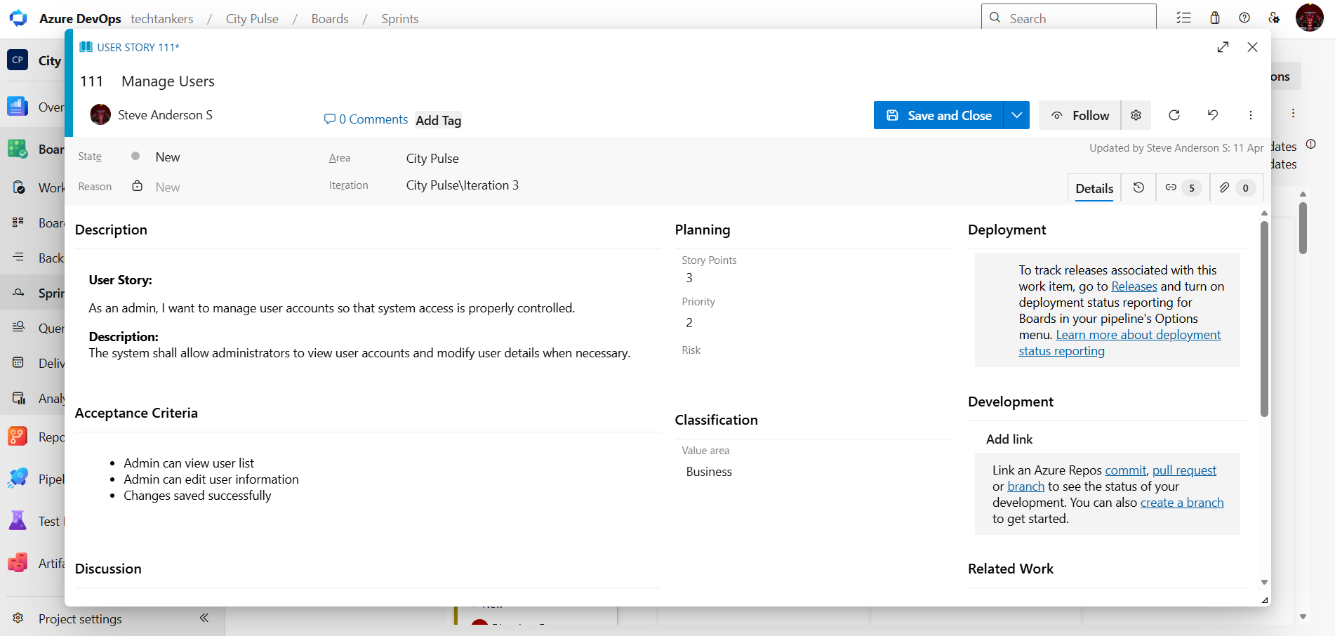

Result:
The Estimation/Story Points is created for the project using Poker Estimation.
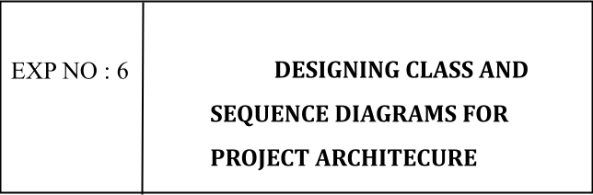

Aim:
To Design a Class Diagram and Sequence Diagram for the given Project.

6A. Class Diagram

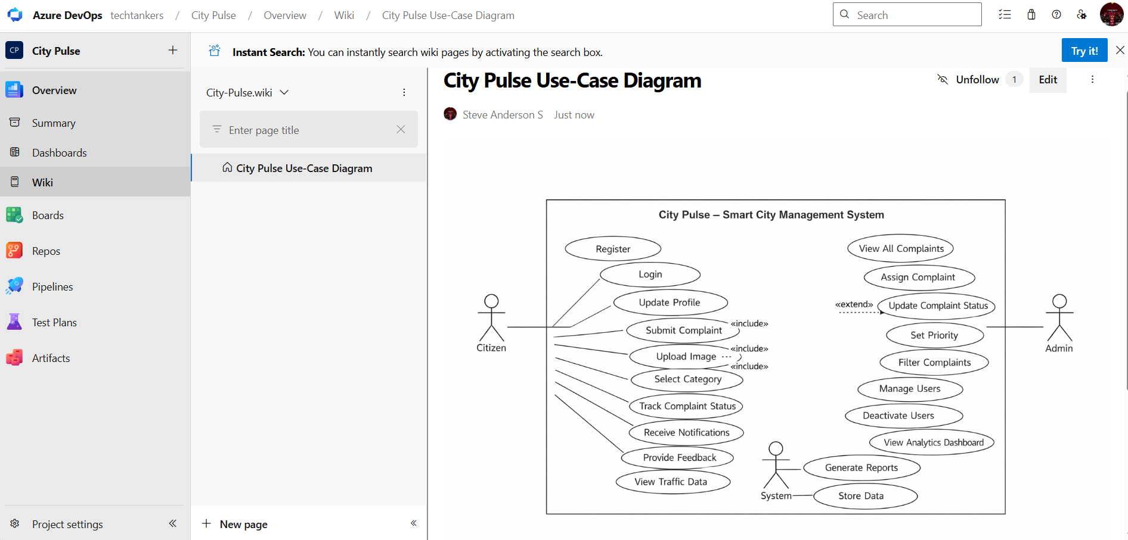

6B. Sequence Diagram

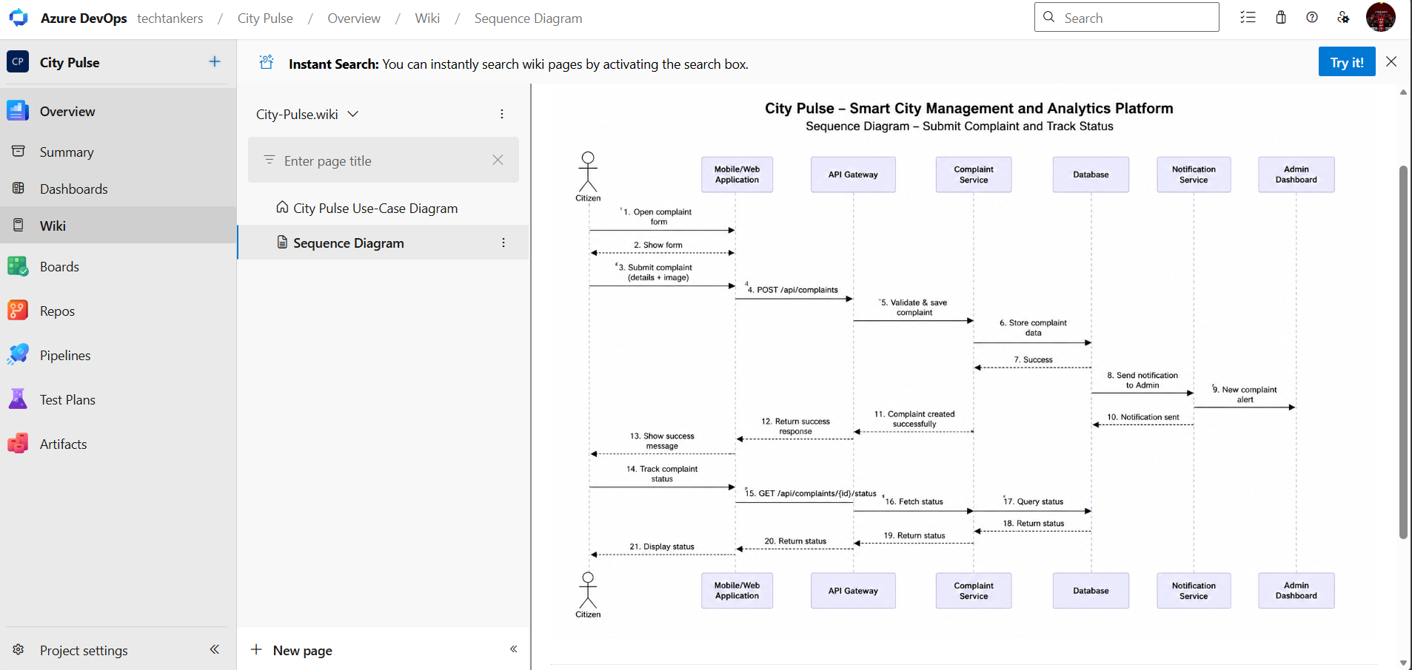

Result:
The Class Diagram and Sequence Diagram is designed Successfully for the City Pulse – Smart City Management and Analytics Platform.

EXP NO : 7 | DESIGNING ARCHITECTURE  AND ER DIAGRAMS FOR  PROJECT STRUCTURE

Aim:
To Design an Architecture Diagram and ER Diagram for the given Project.

7A. Architecture Diagram

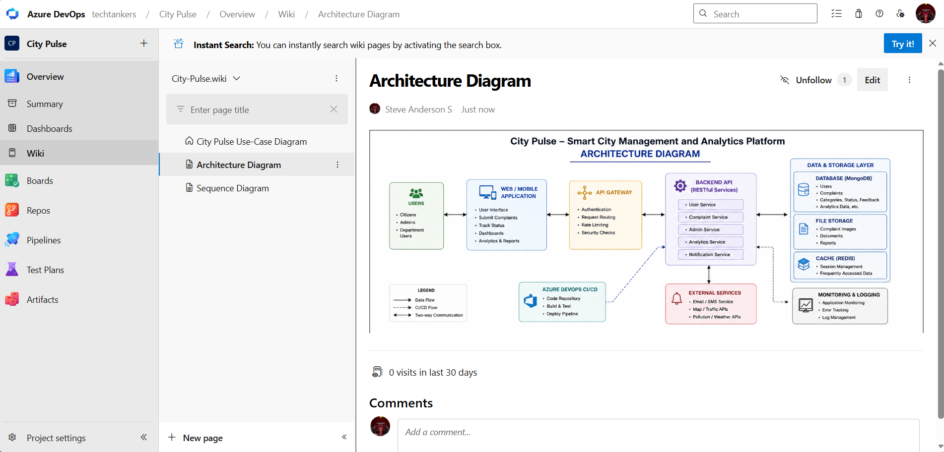

7B.ER Diagram

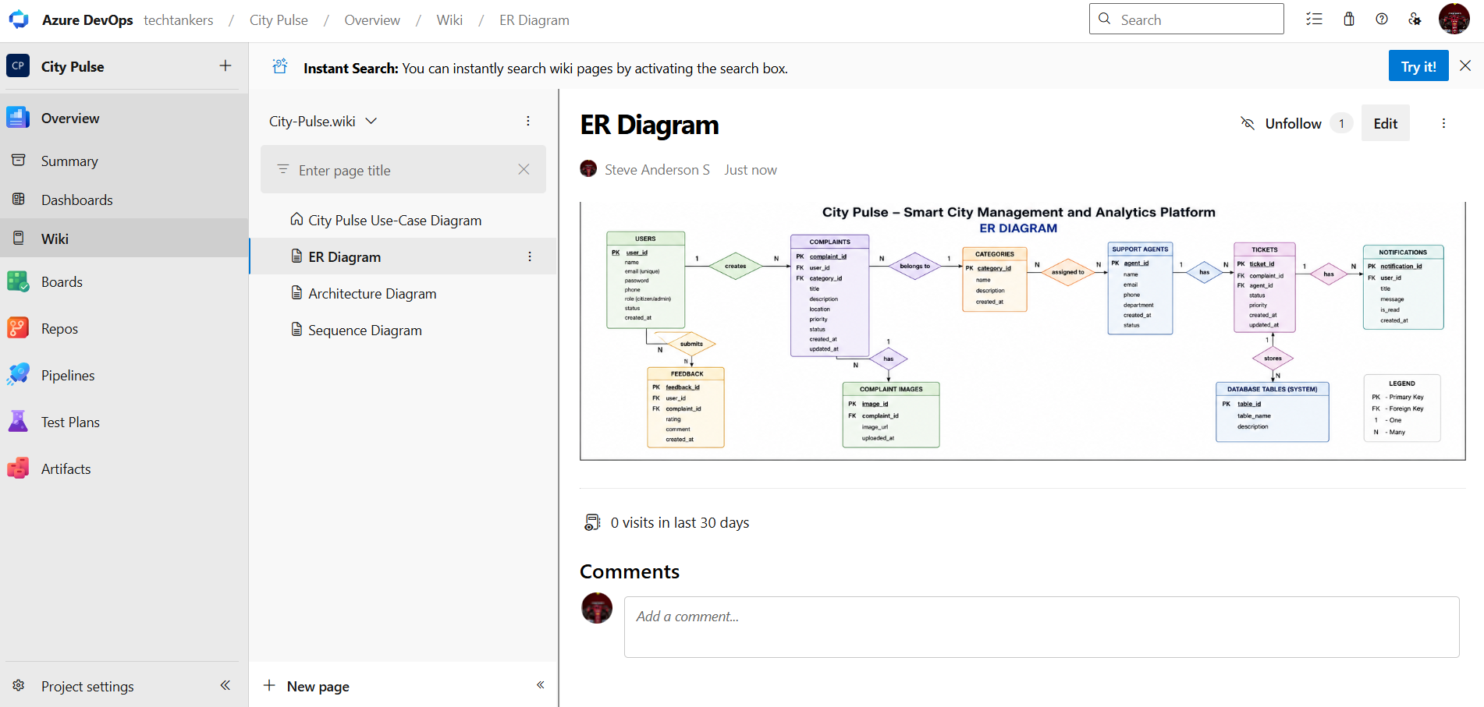

Result:
The Architecture Diagram and ER Diagram is designed
Successfully for the City Pulse – Smart City Management and Analytics Platform.

EXP NO : 8 | TESTING  TEST PLANS AND TEST CASES
Aim:
Test Plans and Test Case and write two test cases for at least five user stories showcasing the happy path and error scenarios in azure DevOps platform.

Test Planning and Test Case Design Procedure

City Pulse – Smart City Management and Analytics Platform

1. Understand Core Features of the Application
The City Pulse – Smart City Management and Analytics Platform includes the following core functionalities:
- User Registration & Login
- Complaint Submission and Tracking
- Uploading Complaint Images
- Complaint Categorization
- Complaint Status Updates
- Admin Complaint Management
- User Management (Admin Controls)
- Real-Time Traffic Monitoring
- Pollution Monitoring
- Analytics Dashboard & Report Generation

2. Define User Interactions
Each test case represents real user activities performed within the platform, such as:
- Registering and logging into the system
- Submitting city complaints
- Uploading complaint images
- Tracking complaint status
- Admin assigning complaints to departments
- Updating complaint priority and status
- Viewing traffic and pollution data
- Generating analytics reports
This ensures the system is tested from an end-user and administrator perspective.

3. Design Happy Path Test Cases
Focused on validating that all features work correctly under expected conditions.

Examples:
- User successfully registers with valid details
- Citizen successfully submits a complaint
- Admin successfully updates complaint status
- Traffic monitoring data loads correctly
- Analytics dashboard displays complaint statistics successfully

4. Design Error Path Test Cases
Negative and unexpected scenarios are tested to validate system robustness and error handling.

Examples:
- Login fails with incorrect credentials
- Complaint submission fails when mandatory fields are empty
- Invalid image upload format rejected
- Unauthorized user attempts admin actions
- Report generation fails for invalid date range

5. Break Down Steps and Expected Results
Each test case is divided into:
- Step-by-step user actions
- Expected system responses and outcomes
This helps verify whether the platform behaves correctly at each stage.

6. Use Clear Naming and IDs
Test cases are assigned meaningful names and identifiers.

Examples:
- TC01 – Successful User Registration
- TC02 – Invalid User Login
- TC07 – Successful Complaint Submission
- TC12 – Complaint Status Update
- TC18 – Traffic Data Display Verification
This improves traceability and mapping to user stories and requirements.

7. Separate Test Suites
Test cases are organized into separate test suites based on functionality.

Example Test Suites:

Authentication Module
- Registration
- Login
- Password Reset

Complaint Management Module
- Complaint Submission
- Image Upload
- Category Selection
- Complaint Tracking

Admin Management Module
- View Complaints
- Assign Complaints
- Update Status
- Priority Management

Monitoring & Analytics Module
- Traffic Monitoring
- Pollution Monitoring
- Alerts
- Report Generation
This structure supports easier execution and maintenance in Azure DevOps Test Plans.

8. Prioritize and Review
- Critical functionalities such as login, complaint submission, and complaint status updates are marked as high priority.
- Test cases are reviewed to ensure completeness, accuracy, and traceability with project requirements and user stories.
- Both functional and non-functional aspects are considered during review.

1. Test Cases

City Pulse – Smart City Management and Analytics Platform – Test Plans

USER STORIES
- As a citizen, I want to register and log in securely so that I can access the platform.
- As a citizen, I want to submit complaints so that city authorities can resolve issues.
- As an admin, I want to assign complaints to departments so that issues are handled properly.
- As a citizen, I want to track complaint status so that I can monitor progress.
- As an admin, I want to update complaint status so that citizens receive accurate updates.

TEST SUITES

Test Suite: TS01 – User Authentication

TC01 – Successful User Login

Action:
- Open Login page
- Enter valid email and password
- Click “Login”

Expected Results:
- Login page loads successfully
- Credentials accepted
- User redirected to dashboard

Type:
Happy Path

TC02 – Invalid User Login

Action:
- Open Login page
- Enter valid email and incorrect password
- Click “Login”

Expected Results:
- Error message “Invalid credentials” displayed
- User remains on login page

Type:
Error Path

Test Suite: TS02 – Complaint Submission

TC03 – Submit Complaint Successfully

Action:
- Login as citizen
- Open complaint form
- Enter valid complaint details
- Upload image
- Click “Submit”

Expected Results:
- Complaint submitted successfully
- Unique complaint ID generated
- Success message displayed

Type:
Happy Path

TC04 – Submit Complaint with Empty Fields

Action:
- Login as citizen
- Open complaint form
- Leave required fields empty
- Click “Submit”

Expected Results:
- Validation messages displayed
- Complaint not submitted

Type:
Error Path

Test Suite: TS03 – Complaint Assignment

TC05 – Assign Complaint Successfully

Action:
- Login as admin
- Select complaint
- Choose department
- Click “Assign”

Expected Results:
- Complaint assigned successfully
- Assigned department displayed

Type:
Happy Path

TC06 – Assign Complaint Without Department

Action:
- Login as admin
- Select complaint
- Click “Assign” without selecting department

Expected Results:
- Error message “Select a department” displayed
- Complaint not assigned

Type:
Error Path

Test Suite: TS04 – Complaint Tracking

TC07 – Track Complaint Status Successfully

Action:
- Login as citizen
- Open submitted complaint

Expected Results:
- Complaint details displayed
- Current status shown (Pending/In Progress/Resolved)

Type:
Happy Path

TC08 – View Invalid Complaint ID

Action:
- Enter invalid complaint ID

Expected Results:
- Error message “Complaint not found” displayed

Type:
Error Path

Test Suite: TS05 – Complaint Status Update

TC09 – Update Complaint Status Successfully

Action:
- Login as admin
- Open complaint
- Change complaint status
- Click “Update”

Expected Results:
- Status updated successfully
- Citizen notification triggered

Type:
Happy Path

TC10 – Update Complaint Status with Invalid Data

Action:
- Login as admin
- Open complaint
- Enter invalid status value
- Click “Update”

Expected Results:
- Error message displayed
- Status not updated

Type:
Error Path

4. Installation of test

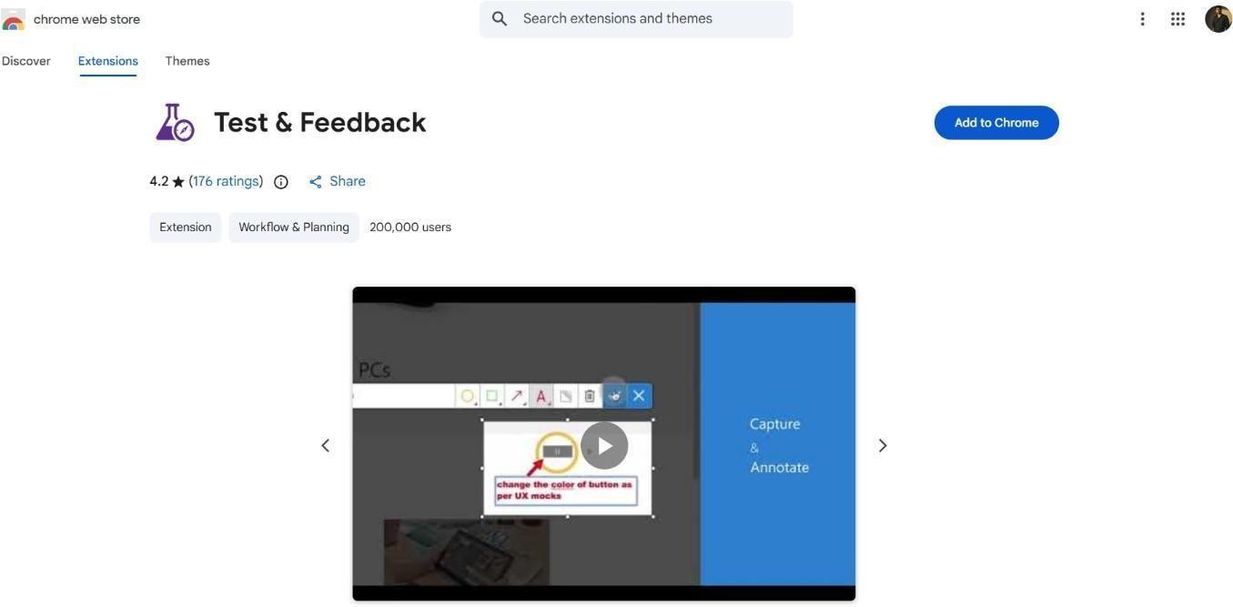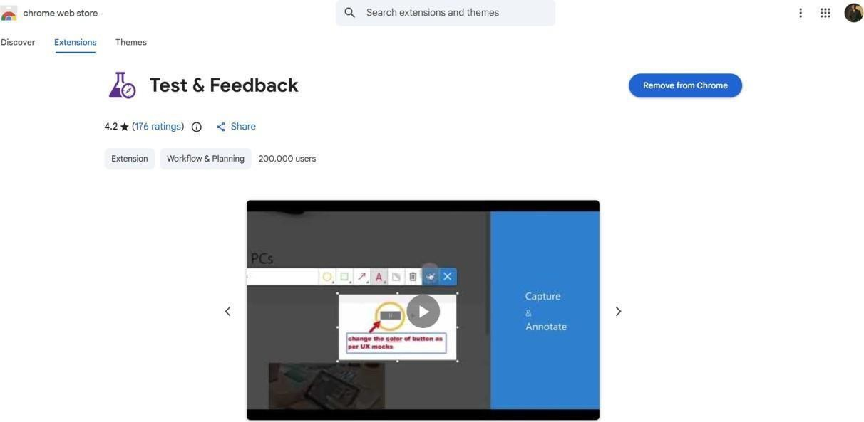

Result:

The test plans and test cases for the user stories is created in
Azure DevOps with Happy Path and Error Path
EXP NO : 9 |   LOAD  TESTING  &  PIPELINES
Aim:
To create an Azure Load Testing resource and run a load test to evaluate the performance of a target endpoint and to create and demonstrate an Azure DevOps pipeline for automating application builds, tests, and deployment.

Load Testing
Azure Load Testing:
Azure Load Testing allows you to simulate high traffic and stress tests for your web applications and APIs to understand how they perform under load. It helps identify performance bottlenecks, scalability issues, and optimize resource usage before deployment.

Steps to Create an Azure Load Testing Resource:
Before you run your first test, you need to create the Azure Load Testing resource:
- Sign in to Azure Portal
Go to https://portal.azure.com and log in.
- Create the Resource
  - Go to Create a resource → Search for “Azure Load Testing”.
  - Select Azure Load Testing and click Create.
- Fill in the Configuration Details
  - Subscription: Choose your Azure subscription.
  - Resource Group: Create new or select an existing one.
  - Name: Provide a unique name (no special characters).
  - Location: Choose the region for hosting the resource.
- (Optional) Configure tags for categorization and billing.
- Click Review + Create, then Create.
- Once deployment is complete, click Go to resource.

Steps to Create and Run a Load Test:
Once your resource is ready:
- Go to your Azure Load Testing resource and click Add HTTP requests > Create.
- Basics Tab
  - Test Name: Provide a unique name.
  - Description: (Optional) Add test purpose.
  - Run After Creation: Keep checked.
- Load Settings
  - Test URL: Enter the target endpoint (e.g., https://yourapi.com/products).
- Click Review + Create → Create to start the test.

Pipelines

Description:
This experiment demonstrates how to create and configure an Azure DevOps pipeline for a City Pulse – Smart City Management and Analytics Platform. The pipeline is designed to automate the process of installing dependencies, building the frontend, and verifying backend execution. By using continuous integration, every change pushed to the repository triggers the pipeline, ensuring that the application is consistently tested and maintained. This improves code reliability and supports efficient development practices..

Steps:

- Connect Repository to Azure DevOps:
  - Created a new project in Azure DevOps.
  - Uploaded the City Pulse – Smart City Management and Analytics Platform code into Azure Repos.
  - Ensured that Azure DevOps can access the repository for pipeline execution.
- Create azure-pipelines.yml in the Repository:
  - Created a new file named azure-pipelines.yml in the root directory of the project.
  - Defined the pipeline configuration for a Node.js based application.
  - Configured the pipeline to install dependencies and build the frontend and backend.

YML-Code

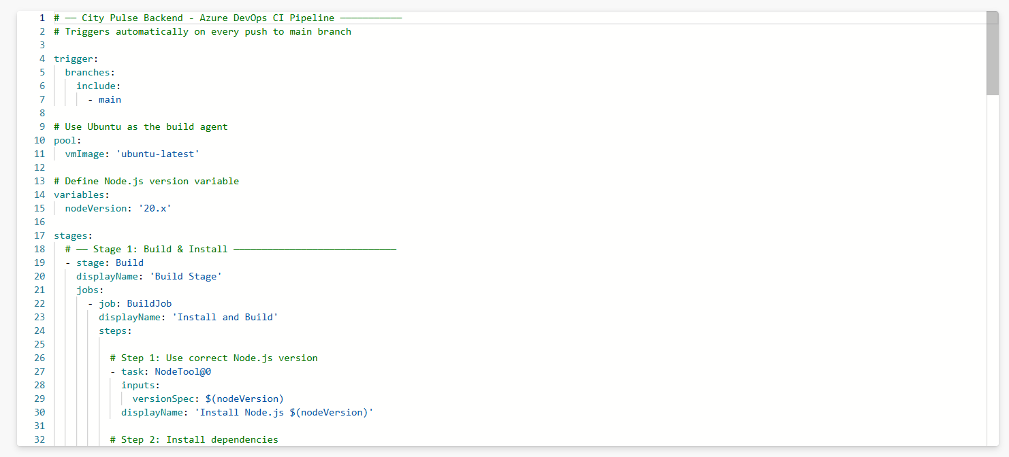

- Pipeline Tasks Include:
  - Installed Node.js environment using NodeTool task.
  - Installed frontend dependencies using npm install.
  - Built the frontend using npm run build.
  - Installed backend dependencies.
  - Executed a simple backend script to verify successful pipeline execution.
- Run and Monitor Pipeline:
  - Saved and executed the pipeline in Azure DevOps.
  - The pipeline was automatically triggered on the main branch.
  - Monitored logs, build steps, and execution status in the Azure DevOps portal.
  - Verified that all stages completed successfully.

Pipeline-Note:
The pipeline was successfully configured and executed. Due to Azure subscription limitations, hosted parallelism was not available. However, the pipeline configuration and execution steps were verified.

Result:
Successfully created the Azure Load Testing resource and executed a load test to assess the performance of the specified endpoint and also demonstrated pipelines in azure devops.

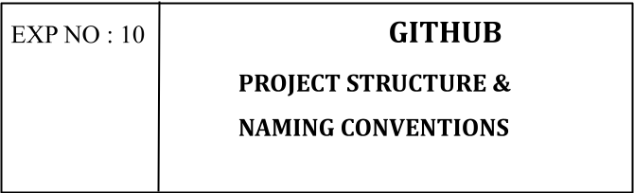

Aim:
To organize and present the folder structure of the City Pulse – Smart City Management and Analytics Platform for easy understanding, navigation, and future development.

GitHub Project Structure

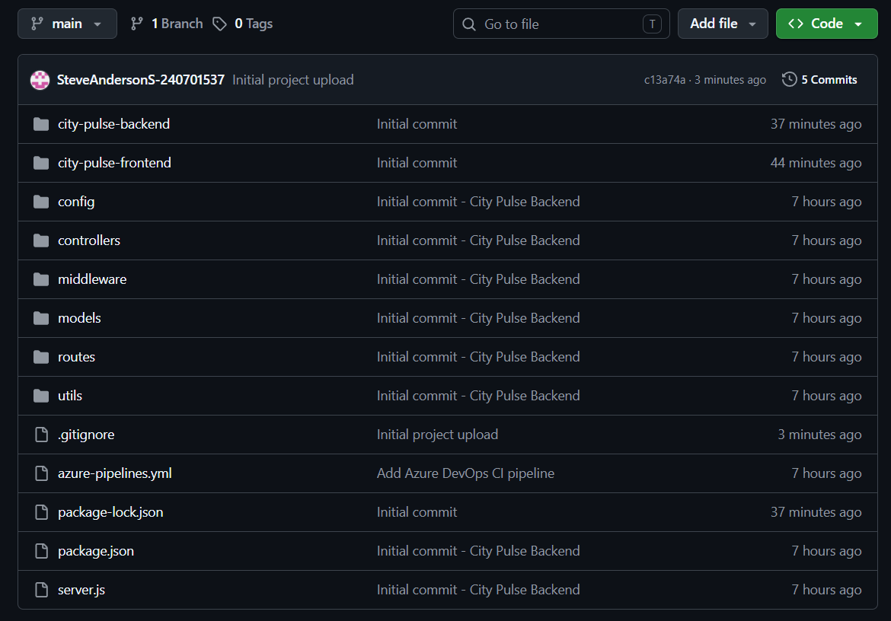

Result:

The GitHub repository clearly displays the organized project structure and consistent naming conventions, making it easy for users and contributors to understand and navigate the codebase.

